

**Handbook Coding Project:**

**‘Stock statistics and graphs’**

|  |  |
| --- | --- |
| **Claire Cornaz**  14-612-048 | **Chasper Kindschi**  XXXXXX |
| **Nico Scharenac**  XXXXXX | **Roman Rahn**  13-297-825 |

**HS18-7,789,1.00 Skills: Programming with Advanced Computer Languages**

**Silic Mario, PhD**

**21st of December 2018**

**Table of Contents**

1. Introduction 1

2. What Software to Install 1

3. How to use the program 2

3.1. Install Python 3.7 and Anaconda 3

3.2. Install Python packages 3

3.3. Open Jupyter Notebook and paste the code 4

3.4. Follow the instructions of the program 5

4. What the program shows 6

5. Variation: Visualisation in a web page 10

1. Introduction

The aim of the project is to create a program, which will provide the user with various statistics and graphs analysing the data of two selected stocks. By using this program the user can have an overview of the stock prices represented either as a simple table, or by different charts useful for technical analysis such as candlesticks or moving averages.

This handbook is divided into four parts: first it explains which software is needed to run the program, second it will give information on how to make the program run, then it will explain how the program can be used and what is shown and lastly it shows you how to integrate this in a webpart.

1. What Software to Install

In order to run the program two softwares need to be installed: Python 3.7 and then the Anaconda package, which will be used to access the Jupyter Notebook. The links for downloading the two software can be found here below:

<https://www.python.org/downloads/>

<https://www.anaconda.com/download/>

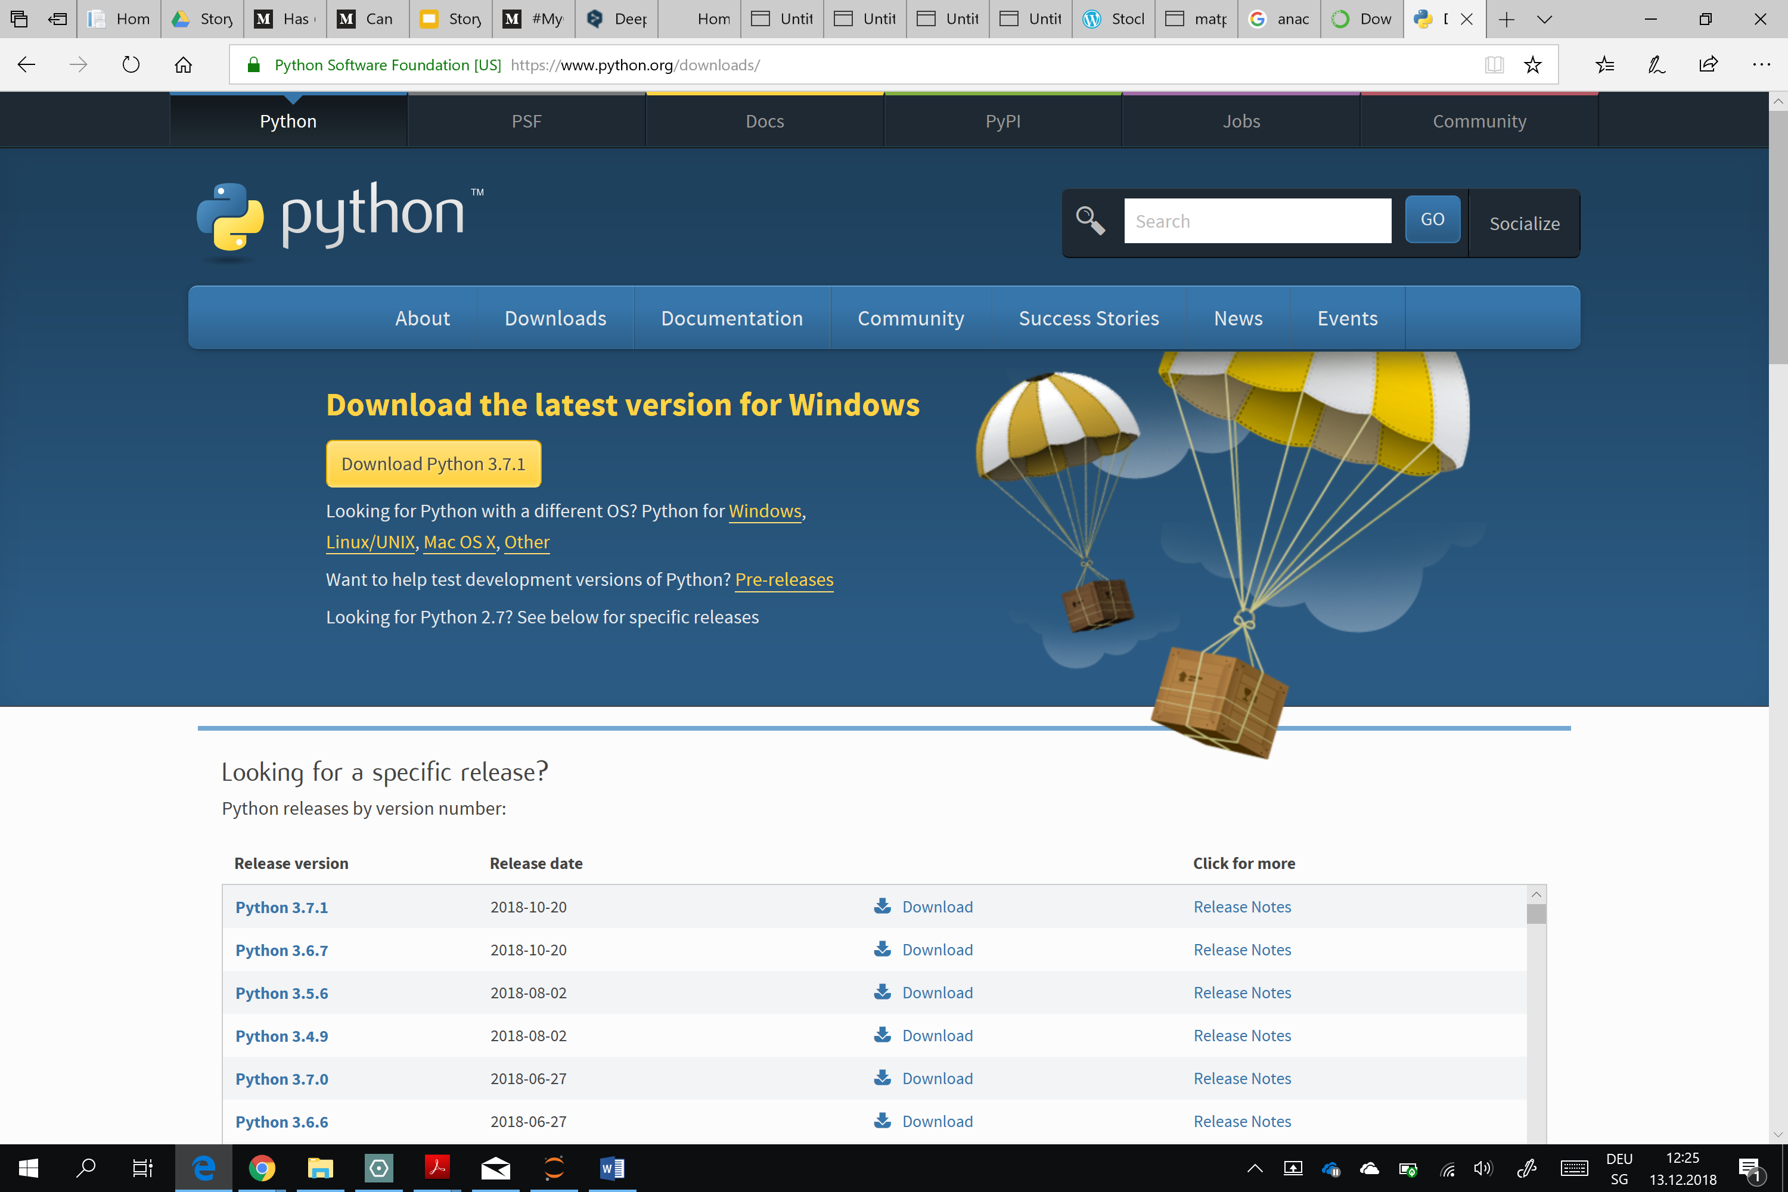

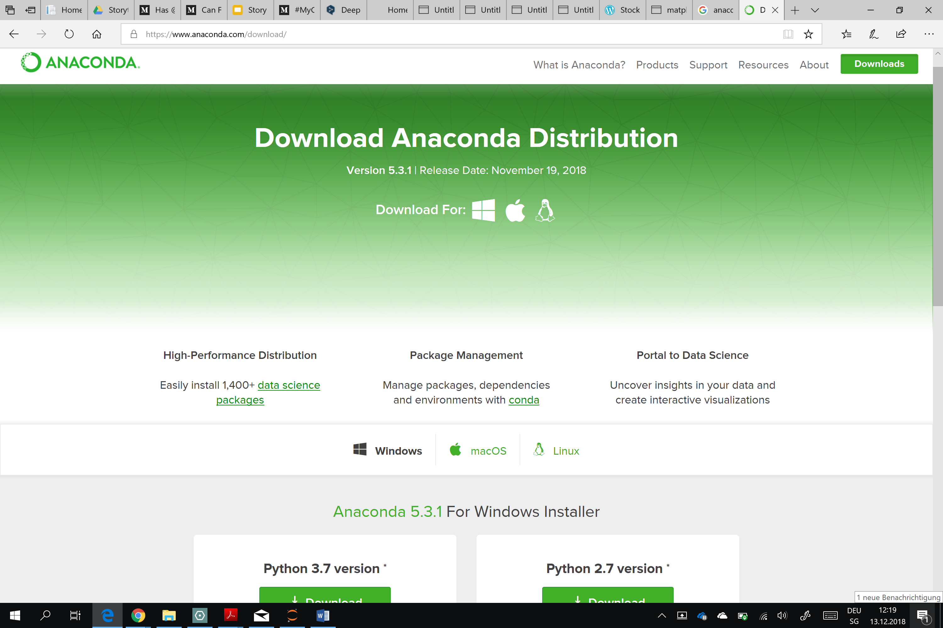

1. How to use the program

The program can be used by following these 4 steps. First the user will need to install Python 3.7, Anaconda and the Python necessary packages. Then the Jupyter Notebook will have to be opened and the code pasted in it. Lastly the user will just have to follow the instructions of the program. The steps are explained in more details below:

* 1. Install Python 3.7 and Anaconda

The first two steps should be easy and straightforward as the installation of Python and Anaconda works in a similar way as for any other program.

* 1. Install Python packages

In order to use some specific functions, it is possible that the user will have to download different Python packages. The procedure for various packages is the same. As an example, here below are the different steps required to install the mpl_finance package:

1. Open the Anaconda Folder in your Start Menu

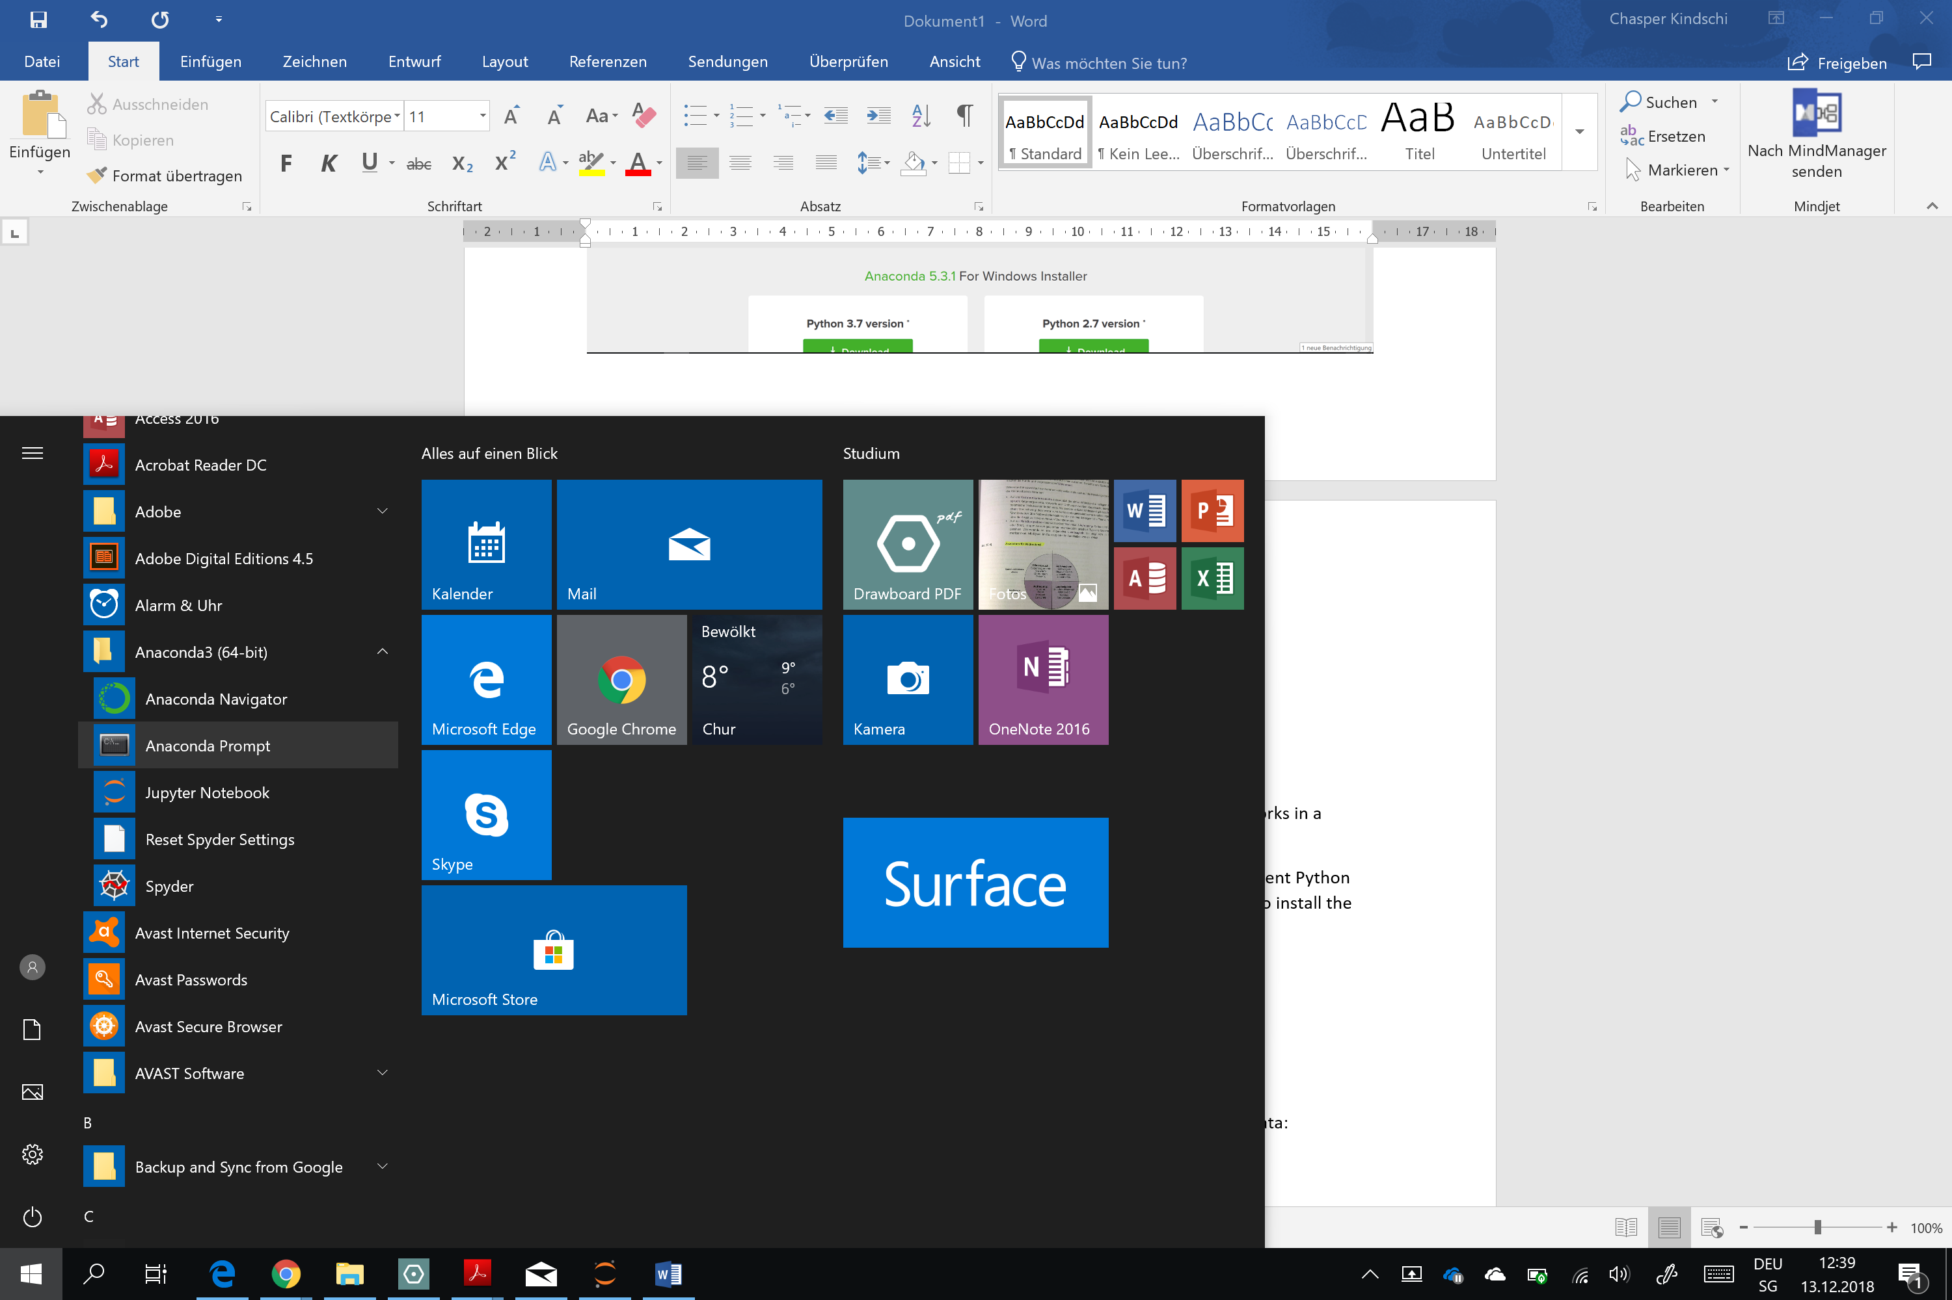

1. Right click on the Anaconda Prompt and open it as ‘Administrator’

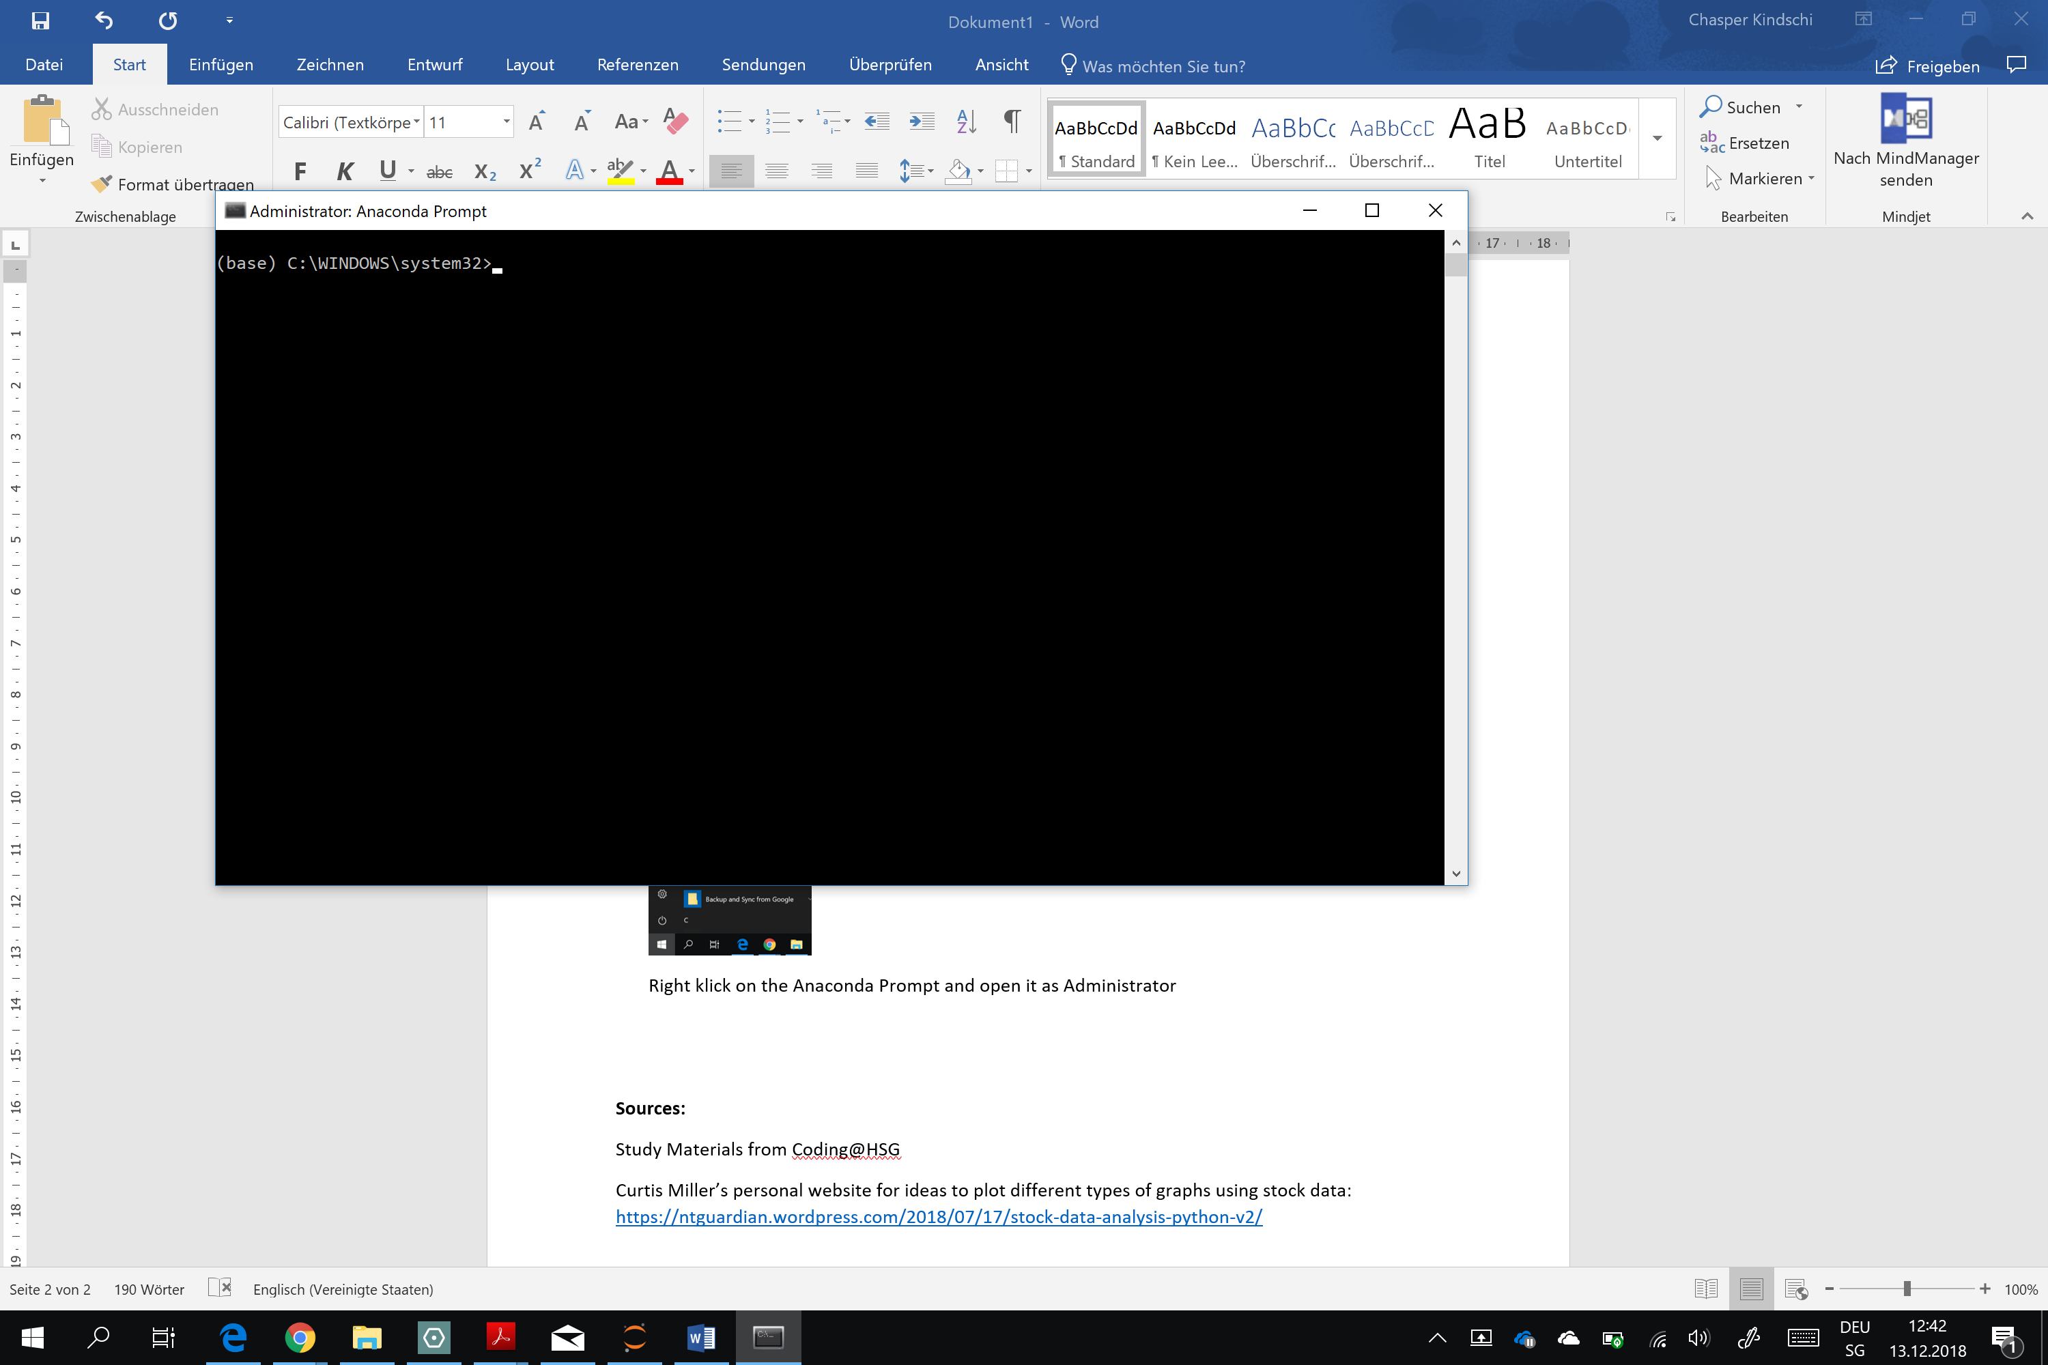

1. Paste ‘pip install mpl-finance’ into the code (without the ‘ ‘) and press enter
2. Repeat the procedure for the other packages by using the following commands:
   * pip install pandas
   * pip install seaborn
   * pip install pandas-datareader
   * pip install matplotlib
   * pip install numpy
   * pip install Quandl
   * pip install DateTime
   1. Open Jupyter Notebook and paste the code

Jupyter Notebook is used to run the code. Here below are the necessary steps to launch it:

1. Open the Anaconda folder the Start Menu and run Jupyter Notebook



Jupyter Notebook is a web-based application and will be open in the user’s default web-browser

1. Open a new Python 3 Notebook

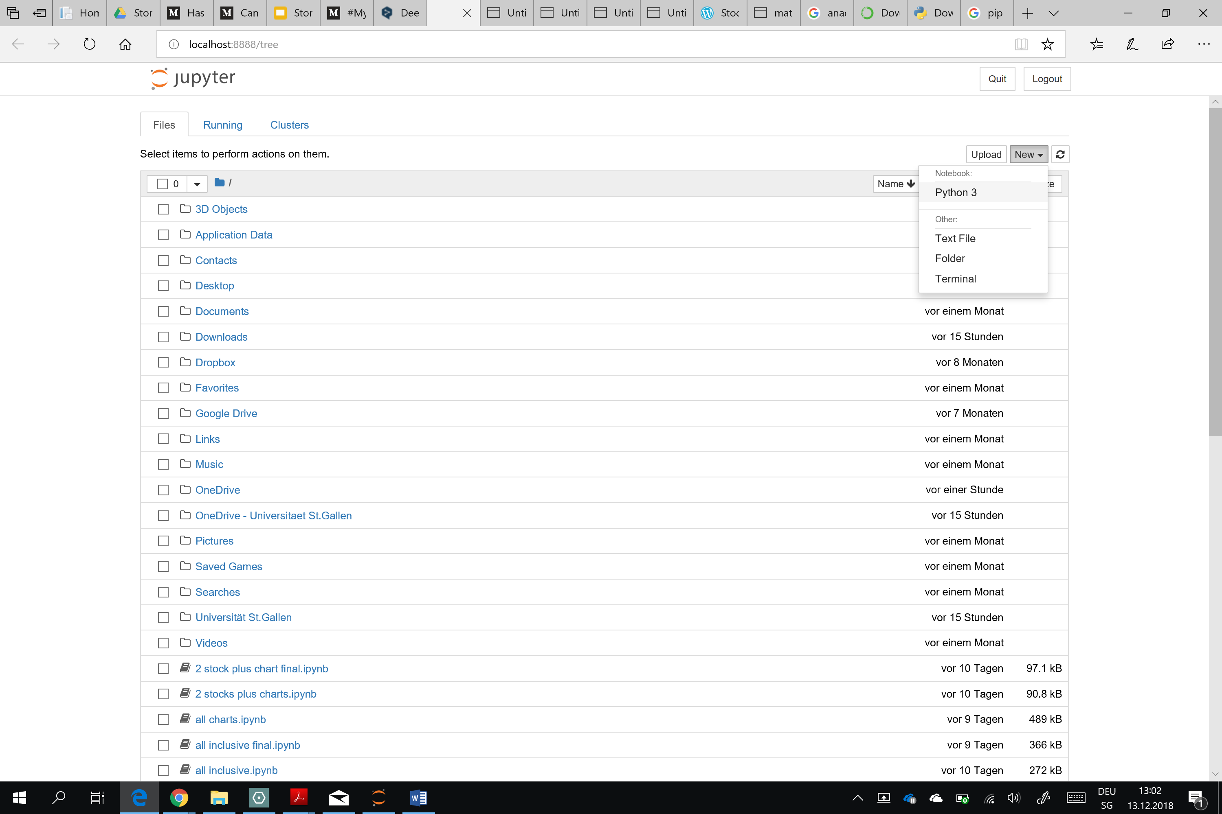

1. Paste the entire code in the field

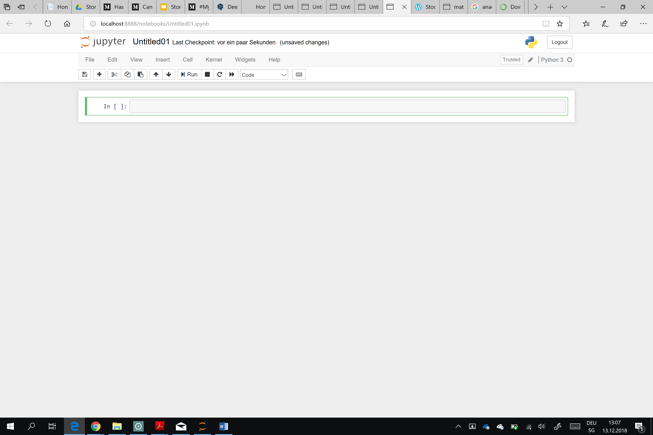

1. Press Shift+ Enter to run the code
   1. Follow the instructions of the program

The computer will need a few seconds to process the code. Once this has been done, the user must make some entries:

1. The program asks the user if he wants to select a specific time period:



The available time range for the stock data depends on the stocks selected. Data is available only up to the year 1996. If the user wants to define the time period, he types: yes, and then presses Enter. If the user answers: no, the program will download the data for the period between 1st of January 2017 and 31st of December 2017.

1. If the user decided to select a specific time period, the program asks to enter the start date:



The correct format to enter the date is as follows: yyyy.mm.dd (E.g. For 1st of January 2017 the user should enter: 2015.1.1

1. If the user decided to select a specific time period, the program asks to enter the end date:



The format to enter the end date is the same as for the start date (Eg. For 31st of December 2016 enter: 2016.12.31

1. The next step is to select for which 2 stocks the user wants to visualize the data. All stocks trading on NASDAQ, AMEX, NYSE and ARCA are available. A list of the S&P 500 stocks with all stocks is available here: <https://en.wikipedia.org/wiki/List_of_S%26P_500_companies>
   1. The program asks the user to input the ticker symbol for the first stock:



* + 1. The ticker symbol of the stocks can be found in the first column, on the above-mentioned link:

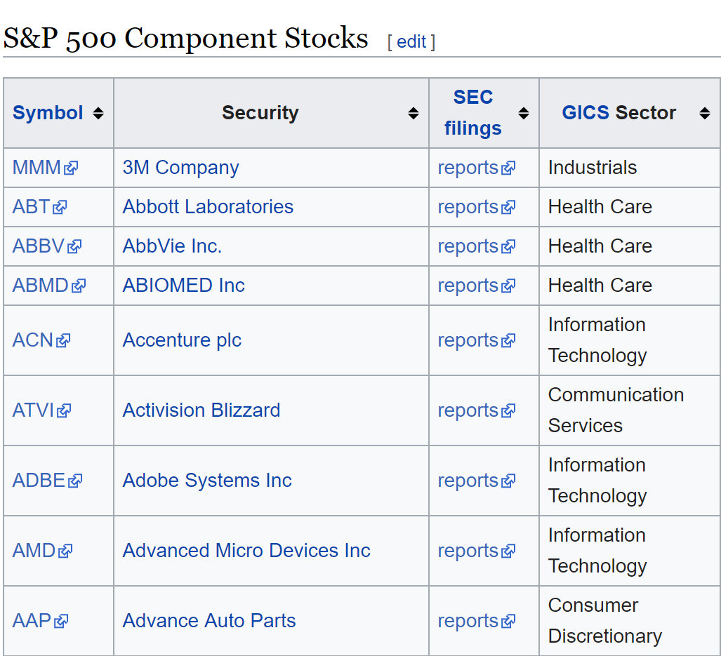

* + 1. The user should enter the ticker in capital letters and then press enter
  1. The same procedure applies for the second stock



1. At this point the program downloads the data from Quandl. The basic data for the two stocks is shown and the program plots several graphs.
2. What the program shows

The program will show different tables and graphs for the two stocks.

1. The first table will show the opening, highest, lowest, and closing prices as well as the trading volume for the first five days of the selected timeframe for the first stock:

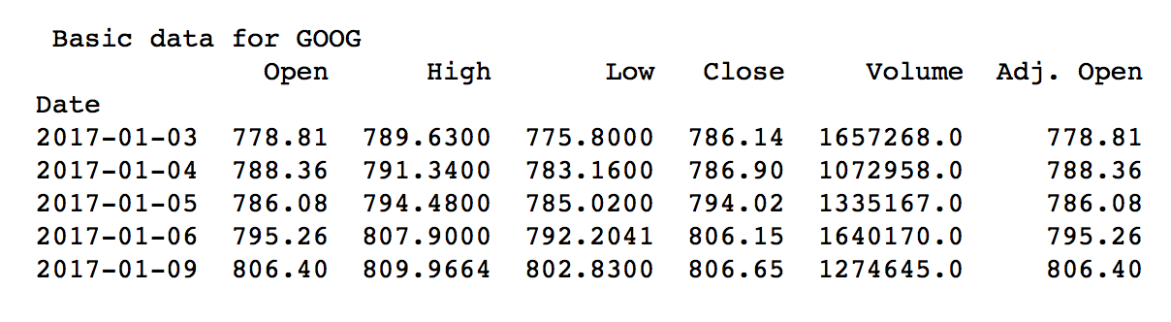

1. The second table shows the opening, highest, lowest, and closing adjusted prices as well as the adjusted trading volume for the first five days of the selected timeframe for the first stock: 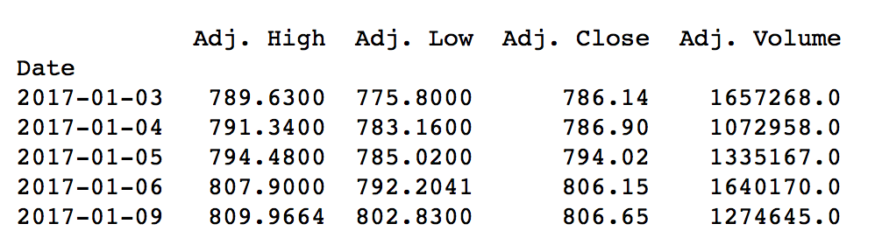

The program shows the adjusted prices as they are commonly used when examining historical stock returns. The stock price is adjusted to include corporate actions (stock splits, tender offers, optional dividends) that happened before the next trading day. Using adjusted prices gives an investor a more accurate representation of the firm’s equity value.

1. The next two tables are the same as in part 1 and 2 except that this time they reflect the data for the second stock
2. The first chart plots the adjusted closing price for the first stock over the selected timeframe:

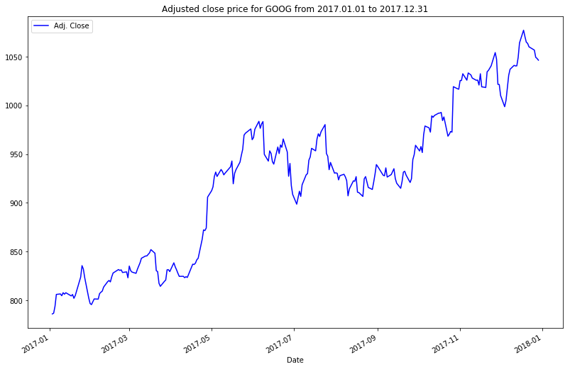

It allows the user to have a visual representation of the price movements of the stock over the selected period.

1. The second chart plots the adjusted closing price for the second stock
2. The third one combines the adjusted closing prices of both stocks allowing the user to compare them: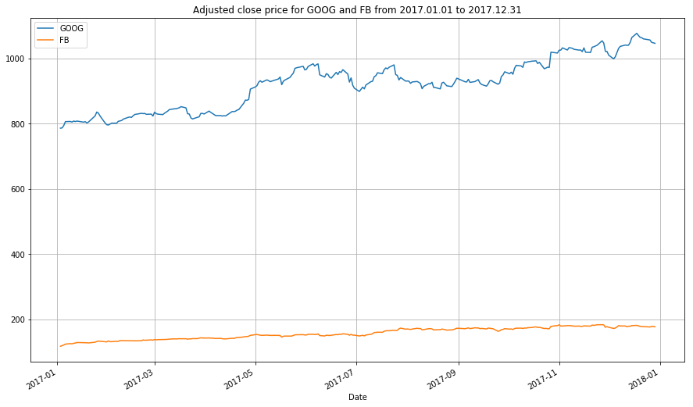
3. The next chart plots the daily returns of both stock: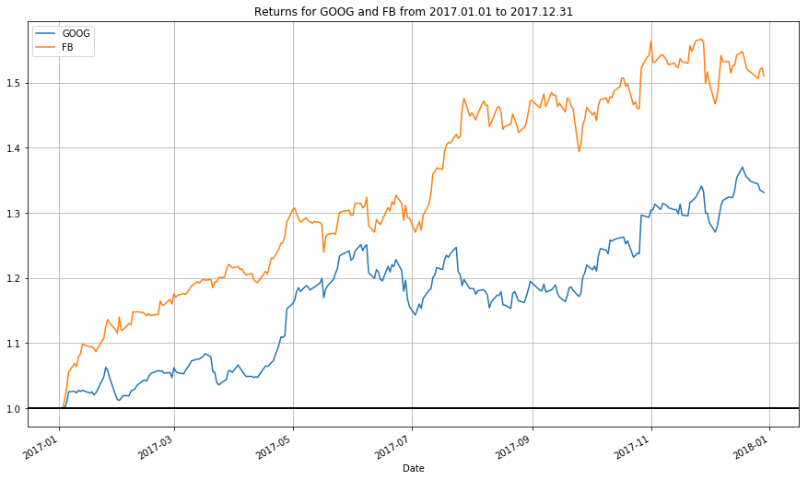
4. Next the program shows four charts representing the data as monthly and daily candlesticks for each stock: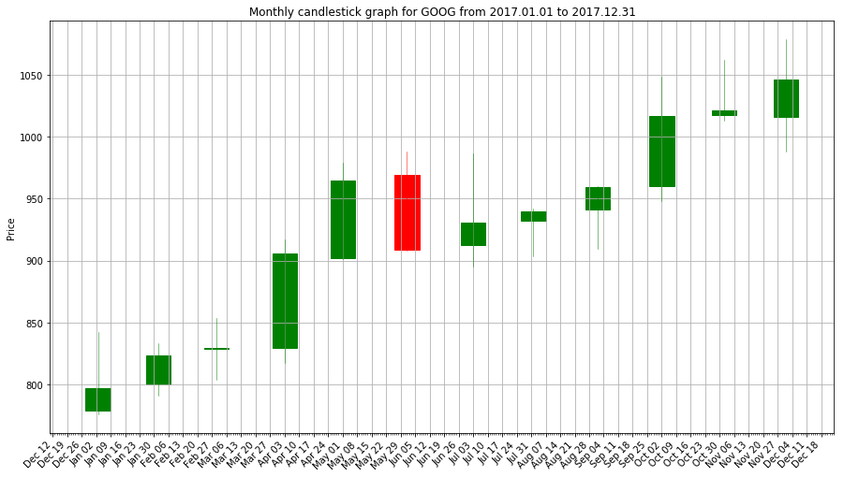

Using candlestick is a useful way of representing the data from the table in step 2. The candlestick represents the price movements of a stock according to a defined period (daily, monthly, yearly). The candlestick appears in green if the stock price closed higher than the opening price and appears in red if the closing price was lower than the opening price. The line represents the highest and lowest price during the period. The size of the candlestick represents the opening and closing price of the period.

A candlestick chart can be used as a representation of investors’ sentiment and is used by technical analysts who analyse the pattern in order to take decision on when to enter/ exit a stock.

1. The last two charts depict the daily candlesticks and the 20 days moving average for each stock: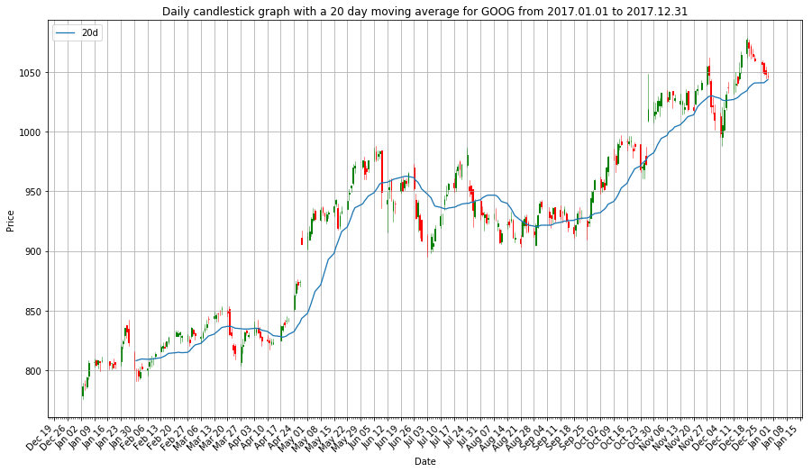

Moving averages are used in technical analysis to help the investors recognize trends in the stock price. Moving averages are commonly used to define a trend direction as well as resistance and support levels. The moving averages smooth the price data in order to form the trend. It is calculated by averaging the 20 last trading prices of each day.

1. Variation: Visualisation in a web page

To run the program in a web page we have used flask. Follow these simple steps to check it out:

Assuming you are on mac osx:

1. Download the zip and unzip it where ever you like: <https://drive.google.com/open?id=1Q6fffVgx5i314KO_eG9CXO17KeZIKHtM>
2. Open a shell, e.g. terminal.app (you can find it in Applications/Utilities)
3. Go to the folder you unzip files (e.g. cd /Users/Nico/Downloads/GroupProject/)
4. Run: pip install flask numpy quandl mpl_finance matplotlib pandas pandas_datareader
5. Then, run: export FLASK_APP=nico.py; python -m flask run
6. set FLASK_APP=nico.py
7. python -m flask run

For Windows Users:

1. Download the zip and unzip it where ever you like: <https://drive.google.com/open?id=1Q6fffVgx5i314KO_eG9CXO17KeZIKHtM>
2. Open the Anaconda Prompt
3. Change the path to the downloaded zip file by entering cd C:\Users\...  
   You can actually copy the path out of the properties of the nico.py file

(e.g. cd /Users/Nico/Downloads/GroupProject/)

1. Run: pip install flask numpy quandl mpl_finance matplotlib pandas pandas_datareader
2. Then, run: set FLASK_APP=nico.py
3. Then, run: python -m flask run

Now, you should have a server running your code.

1. Go to your favorite browser
2. Type <http://127.0.0.1:5000/> in the navigation bar
3. Now, you have an page in front of you where you can enter the information. Try it.

**Sources**

Study Materials from Coding@HSG

Curtis Miller’s personal website for ideas to plot different types of graphs using stock data: <https://ntguardian.wordpress.com/2018/07/17/stock-data-analysis-python-v2/>